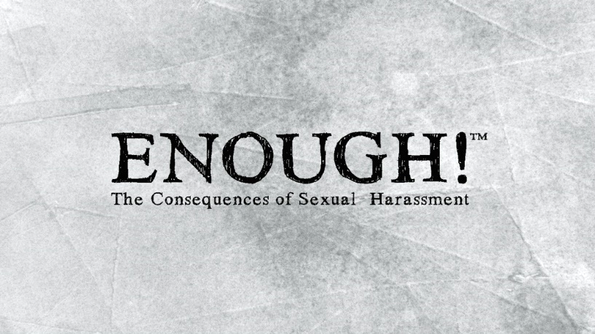 | Let’s be honest. Even after all the training, the public outcry, the legal battles… sexual harassment and sexual misconduct are still very real workplace issues.  How is this possible?  Why are companies still handing out millions of dollars in settlements each year?
The truth is... without knowing the real consequences of workplace sexual harassment; people are less likely to change. It’s not until we fully understand the ripple effect of sexual harassment and how it dramatically impacts each person within an organization… will enough be… enough!
So, what are we going to do about sexual harassment? How can we prevent it?
Besides being fully informed —and professionally sensitive to the policies regarding sexual harassment— the best thing we can do is understand the deep, personal consequences of harassing behavior – to the target of the harassment, coworkers and the organization. Without knowing the consequences—you cannot expect change.
About the Program:
ENOUGH!™ is a completely new approach to sexual harassment training. It is strategically designed in two-parts to deeply engage each learner - with a realistic view of workplace harassment and the fallout associated with a non-compliant culture. ENOUGH! uses a dramatic story line and character interviews to help participants become more aware of the consequences due to the issues surrounding sexual harassment and to help them identify what they should do if they experience or witness a sexual harassment situation.
After completing the program, participants will be able to:
- Identify sexual harassment situations – types and forms (quid pro quo, hostile work environment & visual, verbal, written)
- Understand the consequences of sexual harassment/sexual misconduct
- Take responsibility for their own actions
- Take proactive steps to resolve situations involving sexual harassment
Package Includes:  - ENOUGH!™ Dramatic Video (11 Minutes)  - ENOUGH!™ The Consequences Video (8 Minutes)  - ENOUGH!™ Manager Overview Module (9 Minutes)  - Discussion Generator Video: Sexual Harassment Is...™  - Facilitator Guide (1 & 2-hour agenda options + Manager Module)  - Participant Materials/Handouts  - Self-Study Guide  - PowerPoint Presentation  - 10 ENOUGH! Tip Cards | Target Audience: All Employees  DVD/USB: $995  eLearning: Starting at $10/learner  Video Streaming: Starting at $8/learner

